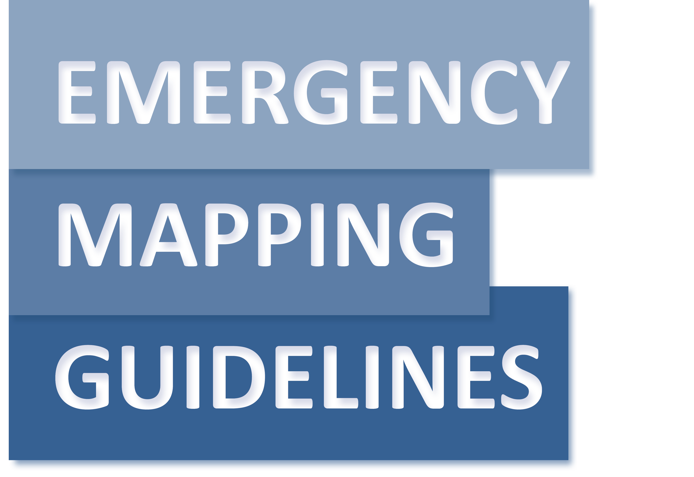
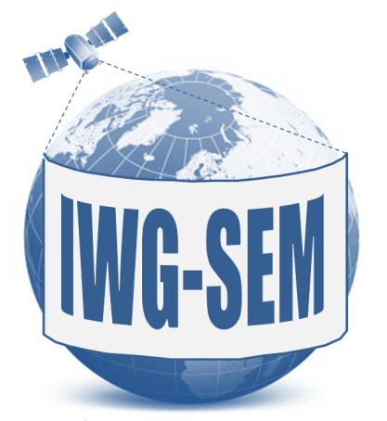
#
Working Paper
Final Draft, Version 2.0 – May 2015

International Working Group on Satellite-based Emergency Mapping (IWG-SEM)
Contents
1. InTroduction 4
1.1 Satellite-based Emergency Mapping Overview 4
1.2 Background 4
1.3 About the Guidelines 5
2. SAtellite-Based EMERGENCY MAPPING (SEM) 6
2.1 DEFINITION 6
2.2 FUNDAMENTAL PRINCIPLES 6
2.3 INTERACTIONS 7
2.3.1 Information exchange 7
2.3.2 Levels of interaction 9
2.3.3 Interaction tools 10
2.4 Sharing of Satellite DATA, analysis and mapping results for SEM 11
2.4.1 Definitions of SEM sharing 11
2.4.2 Sharing of Reference datasets 11
2.4.3 Sharing of satellite data 11
2.4.4 Sharing of analysis 12
2.4.5 Sharing of delivered emergency mapping products 12
2.4.6 Use/licensing/copyright 13
2.5 MAPPING PRODUCT AND INFORMATION CONTENT 14
2.5.1 REFERENCE/PRE-EVENT MAP 14
2.5.2 IMPACT/DELINEATION/GRADING/DAMAGE LEVEL/POST-EVENT MAP 14
2.5.3 SITUATION UPDATE, EVENT MONITORING MAP 14
2.6 Map template 15
2.6.1 MAP (GEOGRAPHIC) FRAME(S) 15
2.6.2 MAP MARGINALIA 16
2.7 DATA Dissemination 17
2.7.1 Naming convention 17
2.7.2 Content of layers 18
2.7.3 Raster Data 18
2.7.4 Vector Data 18
2.7.5 Web Services 18
2.7.6 Metadata 19
2.8 assurance of Capacity and Qualification 20
2.8.1 Qualification/Capacity levels 20
2.8.2 Qualification Self-assessment 23
2.8.3 Assurance of Qualifications and Quality - perspectives 23
3. EVENT-SPECIFIC MAPPING GUIDELINES 24
3.1 Flood Specific Guidelines 24
3.2 1. Scope 24
3.3 2. Reference map 26
3.4 3. Flood extent & impact 30
3.5 4. Monitoring of a flood situation 36
3.6 5. Information for Disaster Risk Reduction 39
4. References 42
5. ANNEX A: IWG-SEM Qualification Check list 43
6. ANNEX B: Glossary 44

InTroduction

Satellite-based Emergency Mapping Overview
When large disasters occur, response organizations, from local first responders to international coordinators, require timely, validated information that can be integrated into information products for efficient communication and understanding of the situation. Over the past decade, satellite-derived maps and geographic information (GIS) files have increasingly been employed and gained acceptance in providing an objective means of assessing disaster affected communities. Imagery provides a means to identify the specific vulnerabilities within a community, intensity of the hazard and extent of impacts prior to more conventional means, such as field inspections. Although many of these products have in the past lacked timeliness, were not easily interpreted by non-imagery experts, or had uncertain levels of accuracy, there has been general consensus in their potential and they are being progressively improved.

Background
As technology and investments in remote sensing advance and the body of experience grows, satellite-based mapping is assuming a more formal and professional posture which has manifested in many community initiatives including, but not limited to the International Charter on Space and Major Disasters (Space Charter), the Group on Earth Observation (GEO), UNOSAT, and UN-SPIDER (United Nations Platform for Space-based Information for Disaster Management and Emergency Response). Identifying a gap in mandates for these organizations, the International Working Group on Satellite-Based Emergency Mapping (IWG-SEM) was founded in 2011 to provide a forum for collaboratively advancing the technical rigor of this discipline. During the initial meeting of interested parties in Hohenkammer, Germany in 2011, the group identified the lack of common procedures in communication and information exchange as one of the major problems needing to be solved. They formed the IWG-SEM to remedy this through the set up of a professional community and resources such as this document.
The IWG-SEM consists of experts representing a wide spectrum of satellite-based emergency mapping (SEM) capabilities, mandates and roles, but all share the common aim to improve the quality and consistency of SEM products. The IWG-SEM aims to do for the communication, analysis of imagery and the development of products, what the Space Charter did for making imagery data available. By the development of a community, common procedures and a collaborative environment, SEM can become a more reliable and dependable information source in the international emergency management profession. Whereas the member organizations may have a direct role in response, the IWG-SEM does not have nor aspire to have any active role in response operations. However, it can participate in an observational role during events and capture “lessons learned” for their integration into future responses.
Having a look at the past decade, rapid mapping experts have faced new challenges for cooperation, especially during large events like the 2004 Indian Ocean Tsunami, Pakistan floods of 2010 and the 2010 Haiti earthquake. In the Haiti response, for example, many different providers generated more than 300 map products in the first 2 weeks, which followed totally different mapping procedures and showed various quality levels. A lack of coordination and common procedures inhibited the community from distributing the workload and systematically assessing impacts and making best use of the imagery available.
In short, there was a plethora of data and expertise, but a lack of a community with a common focus, which could have elevated the combined efforts beyond the sum of their individual contributions. Especially in larger events, improved cooperation, harmonization and possibly even fusion of analytical results, and common emergency mapping procedures could greatly improve quality, reliability and availability of critical satellite-based emergency mapping results. This is what IWG-SEM will continue to pursue and the following guidelines are the first contribution to this endeavor.

About the Guidelines
The aim of the guidelines is to help support an effective exchange and harmonization of emergency mapping efforts leading to improved possibilities for cooperation amongst involved Emergency Mapping Organizations. This will facilitate the convergence of the mapping procedures and thematic content across production teams in response organizations, especially in the early response phases of disaster events. By enabling easier exchange, merging and quality checking of individual data/information layers generated by more than one Emergency Mapping Organization, the final goal of enhancing coordination and community effectiveness can be achieved among those willing to engage.
The guidelines provide a framework, enabling the emergency mapping community to better cooperate during crisis times. To achieve this, the guidelines are structured as follows:
  - Define fundamental principles
  - Establish a procedure for interactions and sharing of data, analysis and mapping results
  - Organize mapping products, templates and dissemination policies
  - Anticipate problems of uncertainty in communication
  - Commit to assurance of capacity and qualification
  - Prepare a glossary for emergency mapping vocabulary

It is anticipated that a second part of the guidelines will be developed at a later stage, focusing on geo-information/map production related to disaster types and identifying a common document structure to be applied to the different disaster types.
These guidelines will be reviewed and updated periodically in order to integrate new best practices and be responsive to evolutions in technology and end-user needs. The IWG-SEM chair has the responsibility to initiate the review. Please send any comments, suggestions or feedback to info@iwg-sem.org.

SAtellite-Based EMERGENCY MAPPING (SEM)

DEFINITION
Satellite-based Emergency Mapping (SEM) is defined as creation of maps, geo-information products and spatial analyses dedicated to providing situational awareness emergency management and immediate crisis information for response by means of extraction of reference (pre-event) and crisis (post-event) geographic information/data from satellite or aerial imagery.
SEM derives mapping products that can be potentially used as input to other phases of the disaster cycle, such as the early recovery and the prevention phases.

FUNDAMENTAL PRINCIPLES
Because there are many SEM organisations which might be involved in SEM of one disaster, it is necessary to define basic rules on how these organizations can best interact.
These fundamental principles describe the way the Emergency Mapping community should interact to create a reliable, trusted and well accepted environment for cooperation, to ensure the highest efficiency of the communication mechanism and to ensure the sustainability of the approach, independent of individual actors.
The SEM entities which commit themselves to cooperation should engage in an open, constructive and ethical manner. Practical examples of such are:
- Cooperation – Provide constructive engagement in all dialogues. The SEM entities should not be passive but should positively contribute to the solution of the problem in hand and based on the technical framework provided in this document. As soon as two or more SEM entities are involved in Emergency Mapping of a particular event, an exchange of necessary information is recommended.
- Openness - Be willing to share information on the activation and any metadata and analysis results to the extent possible, respecting all relevant licensing over data or analysis results. The SEM entities should be ready to share such information whenever their mandate, copyright, intellectual property rights and political/security policies allow.
- Ethics & Integrity – Apply proper referencing, copyright and citations for the sources of information and adhere to branding and marking agreements. The SEM entities will acknowledge (or properly credit) the work and results achieved by others.

INTERACTIONS
In crisis times, information exchange (in particular geo-information) is crucial to the various players in the response community. This section gives recommendations on how information exchange and thus how interactions among SEM organisations can be established and performed.

Information exchange
Information exchange between SEM organisations is essential for subsequent cooperation. The information flow should include all organizations involved in Emergency Mapping. The information exchange should be as automatic as possible and it should contain the relevant amount of information.
SEM information exchange flow has four phases:
- Initial phase
- In-production phase
- Delivery/dissemination phase
- Post-delivery phase

The initial phase, which occurs immediately after the need for Emergency Mapping is requested, includes defining the Area of Interest (AOI) and subsequent satellite imagery tasking. It also takes into account the End User inputs regarding the definition of desired mapping products.
The initial phase of information exchange needs to include information on the location, type of the disaster, the mapping requirements which will include the AOI and information regarding the Authorized User responsible for triggering the SEM mechanism. The appropriate tool for sharing of information during the initial stage is the GeoRSS feed including the links to kml/kmz files or the link to map layer in Google Map. The timeliness of GeoRSS broadcasting is very important: the GeoRSS feed should be released as soon as the SEM mechanism is activated. The advantage of GeoRSS is that it can be ingested by commonly used software (Microsoft Outlook, RSS readers) as well as by specialized GIS software (QGIS, ArcGIS etc.). The kml/kmz file can be inspected and the link can be opened in the most common internet browsers (Internet Explorer, Mozilla Firefox, Google Chrome etc.). Thus the information from the initial phase can be shared not only by IWG-SEM members but also by other interested audiences including civil protection agencies, international organizations, web-based alert systems, etc.
The information available during the initial phase should include the following:
- Type, date, time and approximate location of the disaster. The type of the disaster should adhere to fixed and agreed nomenclature (for example GLIDE Number). The date and time of the disaster should be as precise as possible; at best it should be provided by the Authorized User that activated the SEM. If this is not provided, the time of the disaster should be retrieved from other available sources (websites of civil protection agencies, disaster alert websites, newspapers, local authorities, international organizations working in affected areas, etc.). The approximate location of the disaster can be expressed as points with coordinates in longitude and latitude or as a bounding box or polygon. The points should be the approximate “epicenters” of the disaster that require mapping (e.g. the center of most affected region).
- A link to a kml/kmz file, a GoogleMap map or to other formats of files which can be easily opened in web browsers displaying the AOI for the mapping product extent. The description of the AOI should also include some characteristics of the desired mapping products such as what type of analysis layer should be produced with what type of satellite or aerial imagery.

The in-production phase should include information about mapping products such as the exact coverage, the intended content (e.g. map layers, detailed AOI, satellite spatial resolution category, satellite sensor type, type of analysis), as well as the metadata about the satellite data used. This information set is more advanced and may be limited to those SEM organisations that are involved in the same emergency mapping activation. Because of the intense workload during the height of a response, it might be found difficult to share this information in a timely fashion, especially if it is not generated automatically and substantial human intervention for information sharing is needed. While KML, Google Map links, or similar formats are preferable, other means of communications such as telephones and emails are also effective. The mechanism for this information sharing has to be chosen to best fit the purpose.

The Delivery/Dissemination phase of (geo-)information exchange should be done via web portals of the SEM organisations. The web portals should allow for subscriptions of automatic alerts. These alerts should be issued whenever there is a new mapping product available on the portal. This would allow sharing of the information within the DRM/SEM community, with a broad range of users including the public.
The organizations involved in SEM are encouraged to maintain their own method of dissemination, including, but not limited to, telephones, emails, GeoRSS feeds etc.

The post-delivery phase allows the SEM organisations to collect the feedback from users on the delivered mapping products. The feedback should contain as much details as possible about the usability and accuracy of the maps, timeliness of their delivery and any other useful information which could help to improve the overall usability of SEM.
Whenever possible and appropriate, the findings from the feedback should be shared with other members of SEM. This would encourage improvements and effective cross-learning among SEM organisations.

Levels of interaction
The purpose of the determining the levels of interaction is to efficiently communicate the involvement of the SEM organisations in the disaster. For example, in the case of a small local disaster, there would not be a requirement to set up a dedicated communication channel, because there will normally beonly one entity working on the mapping products. The levels of interaction will become very relevant for larger scale disasters where more than one SEM organisation is involved and where such interaction can bring synergic benefits.
The following list provides the basic description of each level and a potential expansion. The basic level of engagement may be used to describe interactions with IWG-SEM members, or in the general discourse.

- Non-crisis situation:
  - Level 0 – Inactive\unavailable – The SEM organisation is focused on internal projects or other related activities and does not have resources or mandated interest in supporting a specific activation.
  - Level 1 - Monitoring\On Call – The SEM organisation is actively monitoring world or regional activities for potential SEM needs. A person\organization is monitoring news sources and scientific early warning data for trends as well as receiving and filtering inputs from the community. They will use this information to decide when a notification needs broadcasting to other SEM organisations as an alert. The SEM organisation may have a list of Authorized Users, who can trigger the Emergency Mapping Activation.
- Crisis situation:
  - Level 2 – Self-organization (Small scale to medium scale crisis). The SEM organisation is providing support without a need for regulative coordination. Exchange of activity info and bilateral/multilateral communication will suffice to support the situation. Typically, only one SEM organisation is working on the emergency mapping activation. Other SEM organisations will be informed but there is no need for their active involvement.
  - Level 3 – Cooperation of multiple providers (Medium to large scale crisis). Different mapping and/or satellite data providers (i.e. mechanisms like the Space Charter, COPERNICUS, Sentinel Asia and others) are active in the same SEM activation. If a SEM member requires coordination among all providers he should initiate communications among all known cooperators. The coordination roles should be clarified during the initial interaction. The coordination need should be obvious from the initial phase of information exchange, where more than one SEM organisation is involved in the same disaster.
A specific tool to make this information, along with status updates, available to the SEM community should be developed.

Interaction tools
In addition to using GeoRSS/KML as interaction tools as described in chapter 2.3.1, following are other information channels which can be used for effective communications:
- Email exchanges
- Teleconferences using the normal phones and mobile phones
- Videoconferences using specialized teleconferencing equipment (e.g. teleconference rooms).
- Teleconferences and videoconferences over the internet (e.g. Skype)
- Fax
The SEM list of contacts including mailing addresses, phone numbers, videoconferencing capabilities, etc. should be maintained and up-to-date.

Sharing of Satellite DATA, analysis and mapping results for SEM

Definitions of SEM sharing
Useful sharing of the satellite data, baseline layers, analysis results and final mapping products depend very much on the circumstances of the event. It is assumed that SEM organisations will define the parameters of the Emergency Mapping Activation with the End User (s) who requested the mapping products. This information will be shared as needed within the SEM organisation if the disaster event is large enough to warrant job sharing among them. The shared work will be aggregated to meaningful mapping products. The delivery of the mapping products to the user shall honour the End User needs and will not be negatively influenced by the sharing that has occurred among SEM organisations. Finally, in the case of agreed collaboration the sharing among SEM organisations is highly desirable and some basic principles are described below.
When two or more SEM organisations are preparing maps for the same crisis event and if they coordinate the activities through a telecon, it should be clarified how the overall mapping effort can be divided between the different cooperators and which agency representative is the lead. The work allocation will depend on the number of users, the different languages in which the products should be delivered, the number of AOIs, the availability of resources at the SEM organisations. Some possible approaches to the division of responsibilities are: 1) by AOIs, 2) by analysis layers, 3) by processing step, 4) by time of availability of the SEM organisation or 5) by End User group (e.g. using the targeted language). These are some of the options that would allow sharing of the work load and speeding up the mapping process. All related activities should be performed based on the fundamental principles (see 2.2)

Sharing of Reference datasets
Reference datasets would be various geographic features or pre-event satellite data etc. If they are public information and properly documented, it is possible they could be shared between SEM organisations before a mapping campaign. Sharing reference data sets would improve the consistency and quality of products, especially in cases where several organizations are involved in mapping the same AOI. Furthermore, the use of official authoritative reference data to produce post-event analysis and maps would help the End User in integrating results in its operational framework. If SEM organisations would like to share pre-event satellite data during the campaign, they will need to consider the license of the data (see 2.4.3).

Sharing of satellite data
Sharing of satellite data may require special arrangements depending on the range of data licensing. Organizations involved in IWG-SEM should review the conditions of provision of satellite data with the data providers. The IWG-SEM members need to inform the satellite data providers about the IWG-SEM efforts and work with them to determine if there are conditions under which the licenses could be revised to allow data sharing during certain SEM activations.

Sharing of analysis
Sharing analysis layers would allow a) more aggregated products (layers from different SEM organisations combined in one product), b) better quality (exchange layers of low quality with layers of high quality derived by optimal data) and c) cross-check of layers among SEM organisations (more reliable ad hoc products and enabling of offline validation).

If at least two SEM organisations are involved in the mapping, it could be desirable to share the analysis layers of the AOI they are working on. Possible scenarios are:
- There is no overlap between AOIs; each SEM organisation has unique AOIs. In this case analysis is done separately, but the preprocessing of the same/like imagery should be consistent between organizations, or one trusted organization will be responsible for the preprocessing of like data sets. Each organization must be ready to make available the process used to create their analysis layer so discrepancies in processing may be resolved. Each SEM organisation should inform their respective End Users about products available for other AOIs so that he can enrich his map collection with the products coming from other SEM organisations. In case an End User expresses the need to cover the AOIs on which another SEM organisation is working using his map specification, the other SEM organisation should provide the layers to the organization working on the mapping product. All mapping products should be released with the least restrictive distribution possible, possibly using Creative Common Licensing. The proper credits and acknowledgements must be visibly shown on all mapping products.
- There is full or partial overlap of AOIs. In this case, it is important to consider sharing the analysis results with the other SEM organisations. This would serve for cross-checking of the analysis and would enhance the quality of both mapping products. The pre-processing of like imagery should be consistent between SEM organisations, or one trusted SEM organisation should be responsible for the pre-processing of like data sets. Each SEM organisation must be ready to make available the process used to create their analysis layers so discrepancies in processing may be resolved. However, the End User has to receive the mapping products according to specifications agreed to with the SEM organisation doing said processing. These may be changed if different analysis produces different results. This would mean that two or more varieties of maps over the same AOI may exist because of different user specification, such as maps being provided in different languages. However, the cross-checking will allow for the enhancement of all the all maps.

Sharing of delivered emergency mapping products
The final mapping products should be available on the public portal of the SEM organisation or End User organization responsible for the mapping. In addition to sharing the raster mapping products in a proper format (see 2.7.3) allowing them to be ingested in both specialized and generic software packages, it is recommended that the co-operators share the relevant activation metadata in a standard format (e.g. ISO, see 2.7.6)
All IWG-SEM members should provide the mapping products in the formats and with activation metadata which allows them to be ingested in both non-specialized (MS Office, OpenOffice etc.) and specialized software (QGIS, ArcGIS, ENVI, ERDAS etc.). This would allow effective sharing of the mapping products among IWG-SEM members and would enhance the product quality. Organizations involved in IWG-SEM are encouraged to establish a brokering agreement with GEO in order to make discovery and accessibility of the activation metadata, analysis and maps of the AOI easy for the SEM End User.

Use/licensing/copyright
Data/products dissemination policy, which may be different between the different SEM organisations, should be clearly stated in the mapping products. Use of logos is encouraged to provide End User an easy way to identify the emergency mapping framework to which the mapping products are related.
Whenever possible, the IWG-SEM should adhere to the GEOSS data sharing principles:
- There will be full and open exchange of data, activation metadata and products shared within GEOSS, recognizing relevant international instruments and national policies and legislation;
- All shared data, activation metadata and mapping products will be made available with minimum time delay and at minimum cost;
- Providing all shared data, activation metadata and mapping products free of charge or at no more than cost of reproduction will be encouraged for research and education.

MAPPING PRODUCT AND INFORMATION CONTENT
The goal of this section is to define the main types of emergency mapping products and to describe their main information content. These basic definitions will allow emergency mapping organizations to include common main types of information in specific mapping products, indirectly allowing:
- end users to be aware of what types of information they can expect to get from the different emergency mapping products;
- authorized users to request the most suitable mapping product.

REFERENCE/PRE-EVENT MAP
The aim of a pre-event map is to quickly provide knowledge on the territory and assets prior to the emergency. The content consists of selected topographic features of the area affected by the disaster, in particular exposed assets and other available information that can assist the users in their specific crisis management tasks.
The reference map is based on available reference data and the pre-event images, when available. If pre-event images are not available, the reference map will be based on reference data, the post-event image and ancillary information from other resources.

IMPACT/DELINEATION/GRADING/DAMAGE LEVEL/POST-EVENT MAP
Delineation maps provide an assessment of the event impact and extent. Delineation maps are directly derived from satellite images acquired immediately after the emergency event. When relevant, they may be combined with digital modelling and compared with archive information of similar event occurrences.
Additionally, damage level maps provide an assessment of the damage (and eventually of its evolution). Damage level maps are directly derived from satellite images acquired immediately after the emergency event. When relevant, they may be combined with digital modelling and compared with archive information of similar event occurrences. Damage level maps include the extent, type and damage specific to the event. They may also provide relevant and up-to-date information that is specific to critical infrastructures, transportation systems, aid and reconstruction logistics, government and community buildings, hazard exposure, displaced population, etc.

SITUATION UPDATE, EVENT MONITORING MAP
Impact/Delineation/Grading/Damage level/Post-Event maps can be updated to provide an assessment of the evolution of the event impact and extent.

Map template
The goal of this section is to provide general guidelines on the map template structure, e.g. the items that should always be present in an emergency mapping map product (legend, event description, data sources, grid/graticule, etc.), related to both the map (geographic) frame(s) (where the map layers are shown, section 2.6.1) and to the marginalia section (section 2.6.2).
As far as the visualization of the layers is concerned, only overall/general recommendations should be provided, since it is a difficult and demanding task to define unique symbols/visualization styles, keeping into account all the existing mapping cultures (as well as specific map styles contradistinguishing single emergency mapping organizations). More detailed information on symbology/visualization related issues could be provided in the event specific chapters when they will be developed, if general rules for specific disaster types can be identified.
The maps produced during SEM should have two main elements: map frame and map marginalia. They should consistently complement each other.

MAP (GEOGRAPHIC) FRAME(S)
The map frame contains the geographical representation of the map contents (e.g. crisis information, general information, topographic features, etc.), compliant with product typology, legend items and possible detailed user requests. Auxiliary elements like graticule and tick marks are included. Application of the following principles is recommended.

General
- The symbology of each map must ensure high readability; it may be necessary to adapt the symbology to the specific case.
- The chosen symbology must ensure that features are identifiable, distinguishable and linkable to the legend items in spite of the presence of the background image and of other symbols.
- Visibility levels (1 is the more visible), considering that it may be necessary to adapt the visibility to specific cases.
  - Crisis information
  - Settlements, utilities and transportation
  - AOI
  - Other legend items
  - Graticule and tick marks
  - Background image
- Credit the sources (copyright) in the data sources section.

Symbology
- Graphical symbol thickness must be used with care, as it may impact the overall readability. As a general guideline, the more dense the map (e.g. small scale, urban areas, many topographic features are requested by the user), the thinner the graphical symbols to be used (keeping colors and shapes as much as possible).
- Transparency must be used with care, as it will allow the background image color to appear and may easily lead to a change in the final perceived color. As a general guideline, the more light, subtle, faded and uniform the background image is, the more transparency can be used.
- In the case where best practices or de-facto standards are available (e.g. the UN OCHA humanitarian icons, widely circulated and reviewed), the SEM organisation is invited to consider their use in the mapping products allowing the user an easier and faster interpretation of the map without spending additional time in looking at the legend items.

Consistency
- Symbology used in different maps of the same crisis event category should be consistent.
- Symbology used in map frame and legend must be the same.

MAP MARGINALIA
Map marginalia contains the metadata of the map, allowing interpretation of the map frame contents. The key elements are the title/identifier, the cartographic information and the map legend.

The map title must at least contain: the location, type and date of the event. Other information like map type, production date, version number, GLIDE number can be included as well.

The cartographic information must at least contain: the scale ratio, scale bar, north arrow (when necessary), map size (i.e. paper size), and specifications of reference ellipsoid, reference datum and cartographic projection.

The map legend must be completely consistent with the map content (i.e. what is in the map contents is included in the legend and vice versa). It is recommended that the crisis information is on the top part of the legend.
Other sections recommended to be included in the marginalia are:
- Overview inset maps;
- Summary tables with main figures on exposure and consequences in the AOI;
- Text sections: map information, data sources, dissemination restrictions, map production process description;
- Copyrights and logos.

Recommendations for representation of the different thematic layers:
The following recommendations give indication how the layers and their content could be represented. This possibly needs to be adapted to the data availablility and colours of the background image (satellite image, topographic map,…).
1.: Background information
Use a satellite image backdrop or a topographic map. If needed, modify the background layer by adjusting the saturation, transparancy, etc. or include relief shading etc.
2.: Damage/Impact layer
e.g. Normal water extent: dark blue
Depending on the colours of the background layer, the blue tone can be adjusted.
3.: Infrastructure
All infrastructure information should be clearly visible in the map.
City names should be large enough and readable. Recommendation is black for fonts, if needed in a filled box or with white halos.
Road network should differentiate between the different level/quality of roads. Typical colours for roads are white, black and yellow.
Railway lines should be in black-and-white strips.
4.: Critical Infrastructure
Critical assets are often point features, like embassies, airports or bridges. Symbols or icons used to display the location of a point feature should be intuitive and clearly readable. If individual symbols are created, they should also be clearly and intuitively readable for international actors working in the crisis situations. The colour of the symbols need to be in harmonization with the background and should therefore have a certain level of contrast to the background information.

DATA Dissemination
The aim of this section is to define common dissemination formats of the emergency mapping products defined in section 2.4, in terms of both raster/vector datasets as well as web services. This section is focused only on the emergency mapping geo-products to be delivered to end-users and not to intermediate/raw products that could be shared during ongoing activation to facilitate the cooperation/coordination among different actors. The latter component is analysed and described in the sharing section (section 2.3.1).

Naming convention
Filenames, related to both map products and the underlying layers, should be meaningful, without spaces, containing only letters, numbers and underscores. The filename convention should be available and easily accessible to the users, to allow a proper interpretation of the file names in a short time.
The main information which should be contained in the file name is: Type of event, Country, Scale, Print size, Date, SEM organisation. Despite the fact that including these components in the file name will lead to long names, it will allow the user to have a preliminary knowledge of the product content without downloading or opening it.
In the following an example of naming convention (as used in the SAFER project) is described. The agreed naming structure is as follows where the F, G and H segments are optional and hence can be used according to the SEM organisation’s wishes (grey background).
Filename:
SERTIT_SAFER _RICHTER65_P03_14H_carte_situation_50k_A3_18-12-2009_veryhigh.pdf
SERTIT_SAFER _RICHTER65_P03_14H_carte_situation_50k_A3_Date_veryhigh.pdf
A_B_C_D_E_F_G_H_I.J
Part of Name | Rank | Attribute
A | 1 | Map Producer
B | 2 | Funding Project
C | 3 | Exercise name / Charter Call Number if appropriate
D | 4 | Product Number – often this helps as a shorthand for referencing a product
E | 5 | Product Name - Placename and type of map product (event extent, event impact, reference…), if applicable
F | 6 | Scale
G | 6 | Designed Map Print Size
H | 6 | Date of production
I | 5 | Product Export Quality
J | - suffix - | Document format

Content of layers
Specific to each activation request and according to the disaster type and the user request, the following reference features could be included: hydrology, place names and administrative boundaries, physiography, settlements, transportation, industry and utilities. As far as the crisis layers are concerned, their information content should be defined and described in the envisioned second part of the guidelines focused on specific disaster types.

Raster Data
Commonly adopted raster data formats should be used for the raster map product dissemination, e.g.:
- Printable map
  - Full colour ISO format
  - Resolution: high = 300dpi; medium = 200dpi; low = 100dpi
  - GeoPDF file format

- Georeferenced map
  - Full colour ISO A1 format
  - Resolution: high = 300dpi; medium = 200dpi; low = 100dpi
  - GeoTIFF, Georeferenced JPEG file format (with worldfile)

The advantage offered by the GeoPDF format could be taken into account thus, allowing the visibility of the different layers to be managed separately by the users. The use of ISO format will also allow to print the map as A4 map tiles, to allow an easier handling of the map in the field or to cope with the impossibility to print on larger formats.

Vector Data
Vector files of all the reference features as well as the ones derived during the analysis and interpretation stage should be disseminated using standard (or de-facto standard) formats to grant high levels of interoperability, e.g.
- ESRI shapefiles with projection file (.prj)
- Google Earth KML (or KMZ) format

Web Services
In addition to file-based distribution mechanism and trying to move forward from the static map concept, the adoption of OGC compliant web services is highly encouraged allowing a more flexible access to the data, i.e. integration in both desktop and web-based GIS application and several data retrieval options (formats, coordinate systems, geographic subset, etc).

Metadata
The metadata of digital feature data sets (including imagery) that are part of the deliverables have to be compliant with relevant international standards. In addition, geographic projection information must be included in such digital feature sets.

assurance of Capacity and Qualification
The aim of this section is to describe the SEM approach to assure proper qualification of SEM members (comparable to INSARAG approach to classify the capacity of international urban search and rescue teams). At this stage no formal classification of production capacity/qualification is maintained by the SEM. However, general parameters and a self-assessment check-list on capacity/qualification is provided to allow involved/interested partners to self-assess their internal status of capacity. The overall target of this assurance approach is to:
- ensure and improve the general level of quality of the emergency mapping products;
- easily and quickly enable all participants to judge the capacity and qualification level of the other involved parties to adequately dispatch the work load in joint SEM activities;
- provide the users of SEM products with an objective tool to assess the capacity/qualification of a SEM organisation and respective EM products by visualisation of the IWG-SEM logo in combination with a respective qualification status of the VA provider.

The Assurance of Qualification will consist of following parts:
- An IWG-SEM logo that will be used if the mapping is performed following the IWG-SEM guidelines
- A classification of the SEM organisation consisting of 3 categories: light, medium, strong
- Recommendations for a future qualification procedure (to be prepared and carried out when not under emergency conditions and a respective qualification test)

Qualification/Capacity levels

The qualification levels should be simple and intuitive while still being oriented to existing procedures in the disaster management context to easing the understanding for the users domain. Therefore, the approach of INSARAG is adapted to the SEM environment, showing three categories of capacities: light, medium and strong. Those categories summarize the qualification/capacity of the SEM providers. The categories are aggregated to an overall score per SEM organisation, which will be used to assess the SEM qualification level.

Qualification classes and related specifications

The qualification levels summarize the capacity and technical qualification of the SEM provider in different categories. The categories can be used by those SEM organisations preparing themselves for the qualification/classification test. Categories are:
- SEM organisation temporal service availability: light (8/5), medium (8/5<24/7), strong (24/7)
- SEM organisation experience with global mechanisms (e.g. Space Charter): light (none), medium (<5 years), strong (>5 years)
- SEM organisation production capacity: light (single analysis layers), medium (single activations), strong (multiple activations)
- SEM organisation mapping product assurance: light (no QA), medium (only internal QA), strong (external QA)
- SEM organisation product thematic content reliability: light (no validation), medium (internal validation), strong (external validation)
- SEM organisation product delivery time: light (>16h), medium (8-16h), strong (<8h)
- Robustness of SEM production chain: light (ad hoc), medium (partially automated), strong (certified production chain / semi-automated)
- SEM Organisation language skills: light (com. Engl. / map: mother tongue), medium (com: Engl./map partially Engl.); strong (com., coord. Engl./ map routinely Engl.)
- Continuous improvement: light (none), medium (sporadic), strong (routinely)

The three levels of each category are defined in detail as follows:
- SEM Organisation temporal service availability:
  - light = 8 hours / 5 days a week (8/5) or less
  - medium = better than 8/5 but not 24/7
  - strong = 24 hours / 7 days a week (24/7)
- SEM Organisation experience with global mechanisms (e.g. Space Charter):
  - light = no experience at all
  - medium = up to 5 years
  - strong = more than 5 years
- SEM Organisation production capacity
  - light = provision of single Analysis Layer (no full Emergency Mapping Activation on its own)
  - medium = 1 Emergency Mapping Activation on its own
  - strong = more than 1 Emergency Mapping Activation in parallel
- Product assurance
  - light = no quality control before product dissemination / no map template / …
  - medium = internal quality control before product dissemination
  - strong = internal QC following international standards/ ISO certified procedure or internal and external QC (offline)
- Mapping Product thematic content reliability:
  - light = no validations at all
  - medium = internal validations of analysis results (comparable products)
  - strong = external validations of analysis results (comparable products)
- Product delivery time
  - light = First crisis product 16 hours after satellite data reception or later
  - medium = First crisis product 8 to 16 hours after data reception
  - strong = First crisis product less than 8 hours after data reception
- Robustness SEM production chain:
  - light = ad hoc production, manual production; no automatic processes
  - medium = partly automated processes
  - strong = certified production chain / (semi-)automated processes
- SEM Organisation language skills
  - light = basic communication English / Product generation only mother tongue (no English)
  - medium = good communication English / Product generation partially in English
  - strong = very good communication and coordination skills in English / routine map production in English possible
- Continuous improvement
  - light = no user feedback gathered and integrated
  - medium = user feedback sometimes gathered/received and integrated
  - strong = user feedback gathered after each activation systematically and integrated into product / service improvements (routinely)

A SEM Organisation is required to fulfill all subcategories of at least with the level “light”. This would then result in the classification of that capacity as “light” SEM team. The next levels would be “medium” and “strong” SEM team respectively.
Additionally, the SEM Organisation should commit itself to the IWG-SEM guidelines as provided in this handbook, especially the Assurance of qualification section. If so, the SEM provider may use the IWG-SEM logo in their SEM products. This will help the user to easily identify that the SEM provider knows and follows the guidelines. The usage of the logo can be seen as a kind of indirect quality indication as it will show that the SEM provider is internationally embedded in the cooperation strategy and will follow the provided cooperation framework.

Qualification Self-assessment

The Self-assessment of qualification and respective capacity will be performed using the assessment of qualification check list as provided in ANNEX A. The check list is meant as an indication for the SEM Organisation to evaluate their own level of qualification/capacity related to the SEM service provision which can also serve the users as a first impression on the classification of the SEM provider.

Assurance of Qualifications and Quality - perspectives

Applying the principles specified above the IWG-SEM ensures a certain level of qualification and capacity within the community of satellite-based emergency mappers. Due to the given framing conditions of the IWG-SEM, a more complex assurance of qualification and capacity is not feasible at this stage. Nevertheless, the IWG-SEM supports the idea and further evaluates the possibility to supplement the existing approach by implementing additional quality assurance elements such as an external approach to classification of qualification and capacity, inter-comparison exercises of SEM products, cross-validation and cross-checking of SEM products between mapping centers, real-time exercises to evaluate SEM products and to provide feedback for improvements, training curricula or webinars.

The idea to further elaborate the assurance of qualification and quality measures within IWG-SEM is a task to be discussed and worked on in the future.

EVENT-SPECIFIC MAPPING GUIDELINES

Flood Specific Guidelines

Scope
Floods are hydrological disasters caused when a water body (river, lake) overflows its normal banks or embankment because of rising water levels; and/or when, in the case of the saturation or freezing of the soil matrix, water discharges as surface flow or fills morphological depressions due to heavy rain or melting of snow or ice. Furthermore, floods can be caused by backwater effects and by special causes, such as the breaching of dams or extreme marine tides, storm surges or even Tsunamis. A particular type of flooding is the flash flood or a sudden flooding with short duration, typically associated with thunderstorms. Floods and flash floods are also a common consequence of severe storm/frontal systems or the consequence of the landfall of cyclones, which are characterized by a low pressure centre, spiral rain bands, and strong winds. Depending on their location and strength, tropical cyclones are referred to as hurricanes (western Atlantic/eastern Pacific), typhoons (western Pacific), cyclones (southern Pacific/Indian Ocean), tropical storms, and tropical depressions (according to wind speed). Coastal lowlands are particularly vulnerable to storm surges which lead to coastal floods caused by rising sea water levels.
Whatever the cause of the flooding is, satellite data can provide valuable information about flood water extent at a given time and for monitoring the development of a situation over a longer period. By using reference geo-information various forms of flood impact can be estimated, including the mapping of potentially affected infrastructure or settlements as well as flooded agricultural land for example. A unique benefit of satellite-based emergency mapping and monitoring of floods is its scalability through the use of satellites with different sensor types, spatial and temporal resolution and geographic coverage. Low to medium spatial resolution sensors can cover larger areas frequently, however, with coarser pixel spacing, whereas very high resolution sensors typically cover much smaller areas, however, these can be used to map at a higher degree of detail.
Experience indicates that emergency mapping for flood situations typically proceeds at two spatial scales: 1) moderate spatial resolution (100 – 300 m pixels), however, with wide area coverage: so that an “event map” can cover the large areas e.g. affected by plain floods; and 2) high spatial resolution “detail” maps (1-100 m pixels), so that the necessary detailed information for damage/impact assessment can be obtained.
Use of satellite sensors such as MODIS, VIIRS (and in the future, Sentinel 3) with free public data access, offer a good tool for many organizations to generate and disseminate large area flood extent maps, and such products can also provide the temporal repetition rate of daily coverage for monitoring long lasting flood events. A wide variety of sensors, some with free access (Landsat 7 and 8, Sentinel 1 and soon Sentinel 2) and others with commercial/scientific access, can provide the more detailed observations, which will typically also be less frequent. Both types of flood mapping products are often relevant and complementary to each other: an isolated, detailed flood map, for example, does not provide the information needed to determine where and what was the course of a flood or whether the map shows the maximum flood extent or not. However, when integrated with repeated observations and respective monitoring products at a coarser spatial resolution (e.g., at 250 m, via MODIS), detailed mapping can be accurately interpreted as covering a specific phase of the event (e.g. the pre flood-peak situation, or peak, or post flood-peak) for example.
Today, spatially explicit early warning information can be used to schedule data takes from satellites more effectively and with respect to the different flood phases. The precursors detected and analysed by flood Early Warning Systems (EWS) are collected from meteorological satellites, weather forecast and hydrological models. Systems such as the European Flood Awareness System (EFAS) provide complementary flood early warning information up to 10 days in advance, indicating water levels exceeding normal thresholds at river section level. With appropriate geo-information available, flood vulnerability hot-spots can be established from such forecasts.

Reference map
The aim of a reference map is to quickly provide information on a territory and its assets, showing the pre-event/pre-disaster situation. The reference map consists of basic geographic information and selected topographic features covering the area affected by the disaster, in particular exposed assets/infrastructure and other available information that can assist the users in their specific crisis management tasks.
The reference map is based on available reference data and pre-event imagery (archives), if available. If pre-event imagery is not available, the reference map should be based on reference geo-data (topographic data layers), the post-event image and ancillary information from other resources.
With respect to flood events, the specific objective of reference maps is to provide information about the normal water bodies/hydrography in the affected area as they existed before the event. This information is crucial e.g. for distinguishing the flooded areas from the normal water bodies.
Furthermore, the availability of geospatial reference data allows extracting assets/infrastructures that are also needed for the post-event maps.
Definitions:
Theme | Brief Description
Geographic reference data | Refers to any geographic information that describes the pre-event situation (“normal” or “non-crisis” situation) of the area of interest.
Normal water bodies | Indicate the detectable water bodies over a given area derived from the most pertinent data or maps, taking into account seasonal variations when possible

The following content should be included in a flood related reference map and be provided as individual information layers:
Map layer(s) | Reference Map (Floods)
1. Normal water extent/bodies | ***
2. Background information layer (e.g. archive/post-event optical satellite imagery, topographic map…) | ***
3. Points of Interest (as critical infrastructure, important assets… such as Embassies, airports, railroad stations, bridges, hospitals… | **
4. Infrastructure information (e.g. city names, road network, railway net…) | **
5. Information on risk (e.g. vulnerability, exposure, modelled risk areas (HQ100, HQ200),…) | *
6. Thematic information layers (e.g. land use/land cover, height information/DEM), population density, potential evacuation areas, soil information…) | *
*** mandatory, ** recommended, * optional

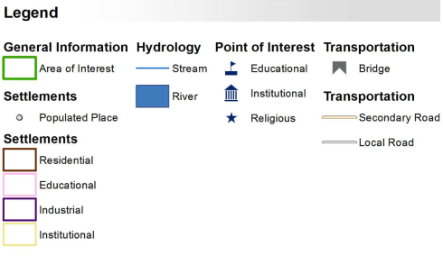
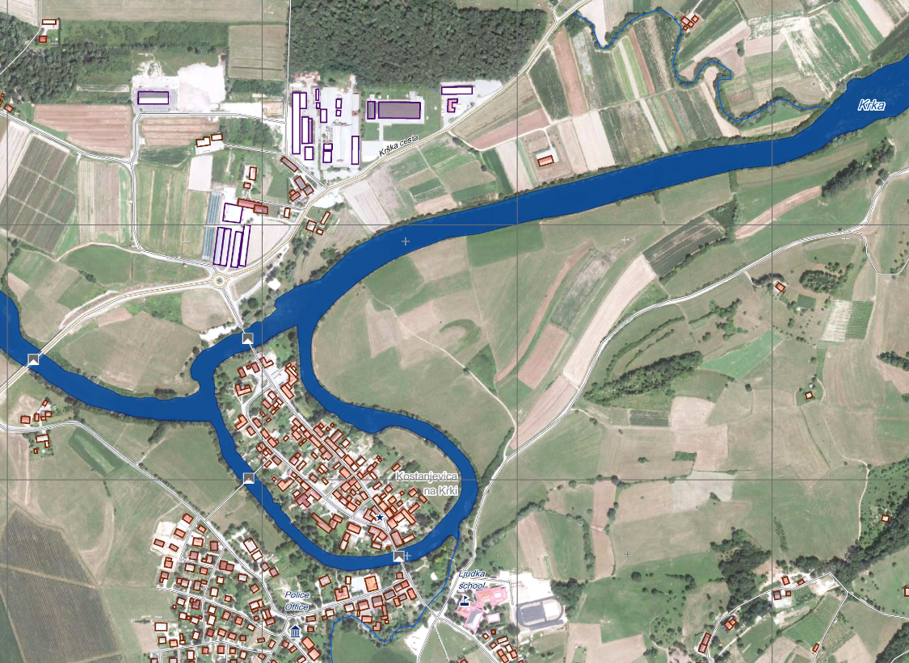
Figure 1: Example for a flood reference map - Source: Copernicus Emergency Management Service - Mapping. http://emergency.copernicus.eu/ (accessed 03/11/15): http://emergency.copernicus.eu/mapping/system/files/components/EMSR102_03KOSTANJEVICA_REFERENCE_DETAIL01_v1_300dpi.jpg)

Vector data:
The vector data should clearly describe/contain each relevant information layer. All vector data should be accompanied by a respective metadata file (refer to section 2.7.6 of the general part of the guidelines).
Vector data filename:
Recommended vector data file naming conventions are described in the general part of the guidelines, in the section 2.7.1.
Recommendations for representation of the flood related layers:
The following recommendations give indication on how the layers and their content should best be represented. This possibly needs to be adapted to the data availablility and colours of the background image (satellite image, topographic map,…).
Water extent: Normal water extent: dark blue. Depending on the colours of the background layer, the blue tone can be adjusted.

Flood extent & impact
Flood extent and impact mapping addresses the mapping of flood waters using the set of input (satellite/aerial) post-event data and reference geo-information layers that is available and adapted to users requirements.
Flood extent mapping itself is different to impact mapping as, despite the fact that both involve the extraction of geo-information using satellite data acquired during a crisis, extent mapping focuses on the analysis of the extent of the areas covered by flood waters only. Impact mapping involves the identification of the potentially affected infrastructure (intersecting the crisis information, i.e. the flood extent, with reference geo-information relating to the affected area) and – if possible the actual assessment of their damage grade, highlighting transport and communication networks, buildings, other infrastructure and possibly agricultural lands affected by the flooding.
The expression “Flood extent” has synonyms that are frequently used in programs such as Copernicus EMS Rapid Mapping’s “flood delineation”. These are dealt with in the Annex B (Glossary). Basically it is a layer highlighting flood waters and hence excluding reference or “normal” water bodies which should be adapted to the present flood’s season. Flood extent mapping provides an assessment of the event’s extent and is directly derived from satellite images acquired immediately after or during a flood event. If a layer does not differentiate between flood and reference water bodies it should be called “crisis waterbody mapping” which can also be informative. When relevant, flood extent layers may be combined with digital elevation models and compared with archive information of similar events. It is always important to respect the original image’s time/date stamp to provide the exact time reference for a given flood map.
Flood mapping can also include a scale of intensity or certainty of flooding in order to allow a differentiation of the crisis information based on specific criteria. An example would be the generation of a flood water class and a class marking “potentially flooded” sectors which are perhaps only partially flooded or where flood traces (moisture traces, mud deposits) are observed, leading to the conclusion that the area most likely was flooded shortly before the satellite data take.
Flood impact mappings can be quite different in character, when carried out in the “natural” or “human dominated“ landscapes compared to when mapping affected critical infrastructure or environmentally sensitive sites. As stated above it requires the availability of reference geo-information layers and the crisis flood extent mapping to support semi-automatic identification of the potentially affected infrastructures and a suitable post-event optical imagery at an adequate level of detail to estimate a potential damage grade. A good way of presenting the results, in addition to clearly displaying them on the map (Figure 2), is in tables within maps or associated to these in tables.
Geo-statistical analysis of the impacted areas can then lead to aggregated flood impact indicators which can integrate socio-economic information and/or landuse/landcover information.
A resume of pertinent flood related information is proposed in the table below:
Theme | Brief Description
Normal water bodies | Indicate the detectable water bodies over a given area derived from the most pertinent data, taking into account seasonal variations when possible
Crisis event water bodies | A layer highlighting all water bodies in a given area including normal water bodies
Flood extent | All floodwater bodies and traces at a certain (acquisition) date except for the normal water body extents
Impact assessment | Map indicating potentially damaged/flooded buildings, infrastructure, flooding of vegetation/agricultural fields, serious bank erosion/channel displacement…

Furthermore, the following content should be included in the map as separate information layers. Depending on the individual user needs or the availability of data, the final product may look different. A level of importance is also given with respect to the appearance of layers within map types:
Map layer(s) \ Crisis map types | Flood Extent Maps | Flood Impact Maps
1. Flood extent | *** | ***
2. Crisis water bodies | ***4 | ***4
2. Normal water extent/bodies | *** | ***
3. Information on impact, e.g. affected infrastructure, urban areas, that can appear graphically in maps and as statistics in tables in or associated with maps |  | ***
4. Points of Interest (as critical infrastructure, important assets… such as Embassies, airports, railroad stations, bridges, hospitals… | ** | **
5. Infrastructure information (e.g. city names, road network, railway net…) | ** | **
6. Thematic information layers (e.g. land use/land cover, height information/DEM), population density, potential evacuation areas, soil information…) | * | *
7. Background information layer (e.g. archive/post-event optical satellite imagery, topographic map…) | *** | ***
*** mandatory, ** recommended, * optional

As general guideline for visualising flood layers it is recommended to display “normal water bodies/levels” on top of the flood extent layer. Use a bright colour to avoid confusion between normal water bodies and flood extents.
If the flood extent layer is highly accurate and reliable in delineation it is recommended to use a semi-transparent, filled polygon with smooth boundaries and no outline to indicate the extent (Figure 2). In cases of low accuracy, use stripes (Figure 3).
Objects located within the boundaries of the flood extent are possibly affected by the flood; however it is often not possible to derive the degree or level of impact on a given infrastructure or asset. Anyhow, there is a higher probability for objects of being affected if they are situated closer to the centre of the flood polygon and thus closer to the centre of the disaster extent and are this deeper submerged by the water. I.e. building “C” is more likely to be affected the flooding than building “A” (Figure 2 / Figure 1). Such difference may be reflected in the interpretation and visualisation of the flood situation. It is important to note that such interpretation always based on model/geometry assumptions and should only be done with great care and good hydrological knowledge of the situation.

Figure 2: Use a semi-transpartent filled poygon to display reliable flood extent layers

Figure 3 Use open stripes for displaying of low accuracy delineation to visualize a degree of uncertainty

Figure 4: Crossing of highly reliable flood layer with linear infrastructre / road layer

Figure 5: Crossing of poorly reliable flood layer with linear infrastructre / road layer

Figure 4/Figure 5 show conceptual considerations and visualisation issues when crossing highly reliable or poorly reliable flood layers with other geospatial features in the map. It is important to note, that any type of crossing of flood extent layers with geospatial reference information should take considerations of reliablitiy and accuracy into account. This is even more the case for flood mappings attached with a high degree of uncertainty.

Vector data:
The vector data should clearly describe/contain each relevant information layer. All vector data should be accompanied by a respective metadata file (refer to section 2.7.6).
Vector data filename:
Recommended vector data file-naming conventions are described in the general part of the guidelines, in the section 2.7.1.

Monitoring of a flood situation
Even though floods often occur as meteorological sudden-onset events, they can last for weeks to even months, as clearly demonstrated by the floods in Pakistan in July to September 2010.
Monitoring the evolution of the flood event is crucial for assessing the rate of increase and/or retreat of flood waters, as well as to identify potential new damages (or changes in damage level) to critical infrastructures (e.g. dam breakage, bridge collapse). By exploiting the increased revisit time of present VHR optical and radar satellite constellations and/or the daily acquisitions of lower resolution sensors (e.g. MODIS), it is technically possible to capture a nearly daily coverage of the whole event, allowing the peak-flood level to be charted.
Consequently, flood extent and flood impact maps can be updated through the analysis of up-to-date satellite imagery. This allows monitoring of the event and provides information for rescue and recovery operations.
Monitoring maps: as a minimum information content, monitoring maps should display the updated flood extent information together with normal water bodies as well as the extent of surface water as of a specific date. The different water layers need to appear with a clear indication of the relevant time stamps, highlighting the imagery acquisition date/time and its technical specifications (GSD, sensor type, etc…).
Monitoring maps can include several previous flood extent information layers. Therefore, particular attention should be paid to symbols/legends that should always grant the map readability, allowing a clear understanding of the areas of water increase/retreat (e.g. no filled polygons to be used) and the related time stamps. Multiple monitoring cycles are difficult to represent in a single map showing the complete flood evolution in all its different stages. A possible alternative for coping with the issue is to reduce the number of flood layers displayed in the map, limiting them to current extent and maximum flood extent (envelope of all the previous flood polygons).
As far as the colour coding is concerned, it is suggested to adopt filled polygons without outlines using different shades of light blue as filling colours (e.g. use the lightest blue for the oldest information, see examples in Figure 6), considering that dark blue is generally adopted for the reference water bodies. Use of transparency may allow a better interpretation of the current flood situation with respect to the previous analyses.
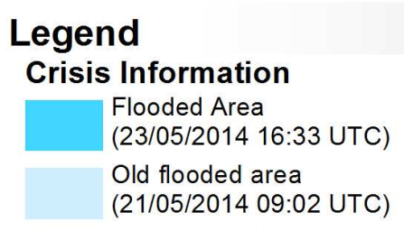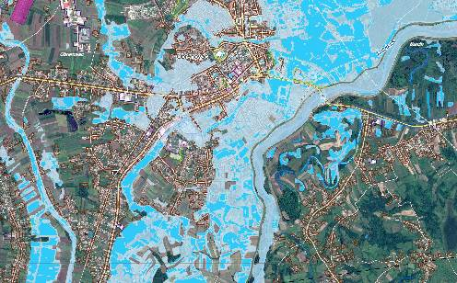
Figure 6: It is suggested to adopt filled polygons without outlines if the flood layers can be derived with a high level of reliablility. For example light blue an show the “older” information while darker blue shows the newer information layer. Trasparency my allow beter interpretation due to better readability of the layer context.

Vector files:
Vector delivery should follow the same vector structure (also in terms of file naming convention) of extent/impact flood maps, to grant consistency with datasets already delivered: normal water bodies and the updated flood extent should therefore be always present.
Vector metadata (i.e. the timestamp associated to each flood polygon) leaves the possibility to derive additional GIS datasets (such as the polygons related to flood increase and draw-off areas compared to a certain date) at later stage, considering the tight time constraints of a rapid mapping service.

Information for Disaster Risk Reduction
Once the emergency phase of a flood event is over – whereby this point in time is sometimes difficult to define exactly – the recovery will start. Once the first responders and relief organisations/agencies have left, very often national and local institutions do not receive sufficient support for dealing with the aftermath of a flood event. The Post Disaster Needs Assessment (PDNA) carried out jointly by World Bank, UN and EU provides the basis for establishing the required donor support for large-scale events, e.g. after the floods in the Western Balkan in 2014. In general, the assessment of significant landscape/surface changes resulting from an event is paramount for any flood situation - independent of scale. If not already included in an activation of and emergency mapping services, the comparison of the pre- to post-event situation imagery reveals the scale and scope of the changes and the impact (e.g. land use, land cover, infrastructure). In practical terms, this can be achieved by detecting the changes between the reference and impact map and/or respective pre/post event imagery.
To guide reconstruction/rehabilitation efforts, the exposure and vulnerability assessment provides the most crucial information for planning and implementation. In cases where these assessments are already available before the event, the re-assessment will reflect the new baseline and indicate where vulnerability hot spots are and previous risk reduction measures have been successful or failed. Exposure maps locate the elements at risk for a probable/historic hazard (HQ50, HQ100). This could already be included in a more advanced reference map. Vulnerability analysis goes one step further by taking into account the sensitivity of assets and people to be harmed (e.g. by floods) and their resilience (this refers to capacities to cope, to be prepared, and to recover).
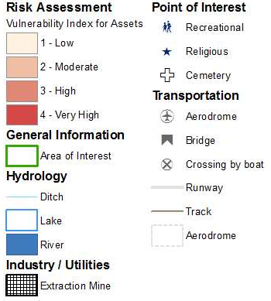
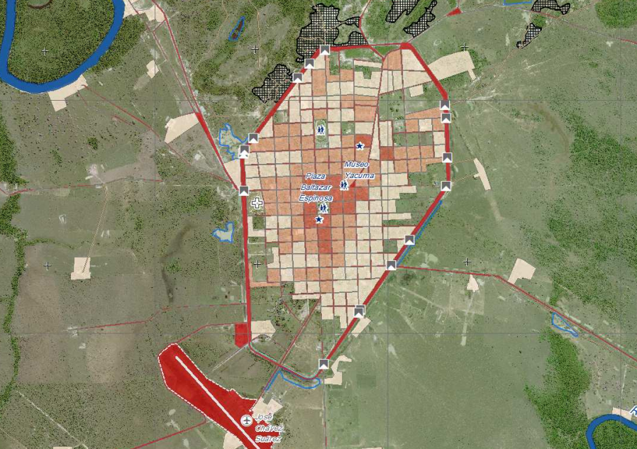
Figure 7: Economic Vulnerability to Floods – Santa Ana del Yacuma, Rio Mamore, Bolivia
The vulnerability index refects exposed assets and estimated building costs (Copernicus EMS, activation EMSN014; http://emergency.copernicus.eu/mapping/list-of-components/EMSN014

The important information for planning risk reduction measures is the location of vulnerability hot spots either in exposure (to guide rehabilitation, relocation), sensitivity , or resilience (strengthen preparedness, coping capacity, or the potential to recovery). At this point, emergency response crosses over into regional development by providing essential information for e.g. land use changes required to reduce the exposure to floods.

References

INSARAG - International Search and Rescue Advisory Group - GUIDELINES AND METHODOLOGY
http://www.insarag.org/images/stories/INSARAG_Guidelines-2012_ENG-_Read_version.pdf

GIO-EMS mapping in rush mode product portfolio specifications
http://web.jrc.ec.europa.eu/callsfortender/index.cfm?action=app.showdoc&id=11662

ANNEX A: IWG-SEM Qualification Check list

Quality category | Level | Specification | Check
Availability | light | 8 hours / 5 days a week (8/5) or less
 | medium | better than 8/5 but not 24/7
 | strong | 24 hours / 7 days a week (24/7)
Experience with global mechanisms | light | no experience at all
 | medium | up to 5 years
 | strong | more than 5 years
Capacity | light | provision of single analysis layers
 | medium | 1 activation on its own
 | strong | more than 1 activation in parallel
Product quality | light | no quality control before product dissemination
 | medium | internal quality control
 | strong | internal QC following international standards
Product reliability | light | no validations at all
 | medium | internal validations of analysis results
 | strong | external validations of analysis results
Product delivery time | light | slower than 16 hours (for 1st crisis product)
 | medium | 8 to 16 hours (for 1st crisis product)
 | strong | faster than 8 hours (for 1st crisis product)
Robust production chain | light | ad hoc production, manual production; no automatic processes
 | medium | partly automated processes
 | strong | certified production chain
Language skills | light | only mother tongue (no English)
 | medium | English (only)
 | strong | English (fluent) and one other language
Continuous improvement | light | no user feedback gathered and integrated
 | medium | user feedback sometimes gathered/received and integrated
 | strong | user feedback gathered after each activation and integrated into product/service improvements (by default)

ANNEX B: Glossary
Activation Metadata | The metadata information describing the important details of the disaster event (for example the type of event, date of event, spatial extends etc.), they should be provided by the SEM Organisation. They are crucial in the initial phase to enable an effective cooperation.
Analysis Layer | The information derived from satellite or aerial imagery separated in different, consistent digital GIS layers (e.g. street net, points of interest, disaster extent, damage assessment).
Authorized User | An organization with the right to trigger a generic data procurement mechanism or a generic emergency mapping service for the disaster.
Collaborative Mapping | Creation of maps for the same disaster by more than one SEM Organisation, either in separate lines or in a commonly coordinated and harmonized way (by dispatching the job by AOI, Analysis Layer, time of engagement.
Data Procurement Mechanism | The mechanism through which the imagery are acquired (for example International Charter, Sentinel Asia, GSC-DA GIO-EMS etc.)
Satellite-based Emergency Mapping or Emergency Mapping | Creation of Mapping Products/value adding based on satellite or aerial imagery dedicated to emergency management and response.
Emergency Mapping Activation referred also as  SEM Activation or Activation | The value adding activity with the aim of performing Emergency Mapping using satellite-based or aerial imagery as the main source of data. The Emergency Mapping Activation is usually triggered by the Authorized Users before (in the case of reliable early warning), during and after the disaster.
SEM Organisation | The organization with the capacity to perform Satellite-based Emergency Mapping or Emergency Mapping  Also called: “Value Adder”, “Value Adding Company”, “Rapid Mapping Entity”.
End User also User | The organisation using the Mapping Products for their needs, typically related to disaster management or humanitarian crisis.
Mapping Product  alternatives:  Map Product  Disaster Map  “emergency response product” (Safer),  “product” (GIO-EMS, DLR-ZKI), “image product” (International Charter),  “cartographic products “ (SERTIT) | The geographic digital datasets and ready-to-print layers and/or maps containing the information about disaster extent, damage extent, damage grade complemented with conventional map elements.  Also called:  “Emergency Response Product” (SAFER),  “Product” (GIO-EMS, DLR-ZKI),  “Image Product” (International Charter),  “Cartographic Product“ (SERTIT)
Product Metadata | Information associated with a specific Mapping Product, describing the content, specifications and characteristics (ISO, INSPIRE).
AOI | Area of Interest. The part of the earth surface to be covered by Emergency Mapping.
GeoRSS | It is the web feed with the geolocation embedded into them. Geolocation can be expressed as point, line or polygon. They can be consumed by both common feed aggregators and geographic software (including map generators).
GLIDE Number | Globally common unique ID code for disasters (see www.glidenumber.net)

Critical infrastructure should be clearly indicated by appropriate, intuitive symbols and adequate colour coding. A good option is the free UN OCHA set of humanitarian symbols (icons): http://www.unocha.org/top-stories/all-stories/ocha-launches-500-free-humanitarian-symbols
Alternative to 1. Flood Extent
http://en.wikipedia.org/wiki/2010_Pakistan_floods

