Dynamic Objects in OSM/HOT
Data Structure - Draft Input
Engelbert Niehaus Creative Commons License
created 2015-05-27 last modified 2015-11-17

Objective
How can dynamic objects be represented in OpenStreetMap/Humanitarian OpenStreet Map? Draft requirements and constraints analysis

Requirements and Constraints

Data Traffic & Server Infrastructure
Real-time data could create a lot traffic on existing IT-Server Infrastructure (OSM).

Conclusion:
- Real-time data should processed and offered to the users by alternative IT-Infrastructure and Servers and linked to the OSM-data
- OSM Records contain an attribute for real-time data e.g. an URL
https://www.dlr.de/tracking/object.php?objectid=123456&timeindex=....'
How do real-time-servers and OSM servers are linked.

Link between OSM-data and Real-time-data
OSM database records provides the initial state of geospatial objects and processes are represented by real-time-data.
- real-time-data overwrites some property (location of an truck)
- real-time-data adds additional attributes e.g. fuel, up-time, … that is necessary for decision making processes, ...

Time Stamp, Space-Time, Tracks and dynamic geospatial Processes
A track is a sequence of space time coordinates
=latitude =longitude =altitude =time
A track is a sequence of space time of these coordinates.
as a track of space-time-points.
OSM provides the geospatial information needs a time stamp e.g. for, i.e. the initial state. This time stamp for the initial state, the real-time-data will show the alteration of the moving object (e.g. truck) in space in time.

Joining two or more tracks facilitates the representation of the alteration of the cost-line.

The following figure show 4 tracks (blue) with 3 space-time-coordinates with the time stampsInterpolation of track points (red) with the same time index could represent the alteration of cost line e.g. after a flood event. Permanent alterations of the cost line due to the impact of a tsunami will be stored in OSM again
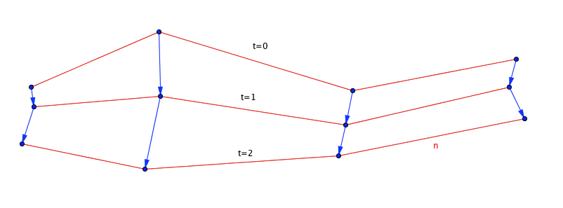
Figure 1: 4 Tracks representing the alteration of costline

Conclusion:
- The real-time-data facilitates the representation of processes in space and time.
- OSM provides initial geospatial state of objects containing the e.g. static properties moving object like transport capacity.
- OSM needs to have a reference, where to access the real-time-data. Real-time-data could include parameters that are necessary of operational planing like 'fuel left','Name of the driver', 'destination',.....
- For different disasters the real-time-data may be provided by different servers. The availability of real-time-data must be updated by the real-time-data provider in OSM.
- Space-Time-Point is a basic element for dynamic representation.
- Tracks: Multiple Space-Time-Points create tracks.
- Costline or Polygons in general (e.g. representing lakes, impact zones, ...) and the alteration in space and time can be representing by combining multiple tracks. Point history Points with the same provides the representation of the digital objectsAdding time index to geospatial information allows to create track

Digital Signature on Database Record Level
Some disaster information need approved by official authorities, especially when aggregated information could create panic reaction in the public. For such critical decision using a validation concept of ''crowd validates crowd'' is not acceptable. Levels of trust may be added to crowd sourcing data by digital signature. On the other hand official data may be wrong due to changes and new impacts. Freezing data of authorized data at a certain stage is not a feasible option.
Conclusion:
- Records in a Database need a digital signature, governmental organizations sign validate records with their privat key. Everyone is able to check if the validated record is still unaltered.
- Alteraring records is possible/allowed,
- altered records even by unauthenticated users make the signature invalid.
- Versioning system for database records is necessary. because it allows users to refer to the last validated record in the database which is different to last version of the record.
- tools are available to represent the alteration and the history of records (like versioning system for software (Subversion,CVS, …) or versioning of creative commons document used in Wikipedia)
- Open Source Tools: GnuPG, Public-Private-Key Methodology

XML-Records for Real-time-Data
In real-life applications there might be a demand for additional attributes in the real-time-data nobody thought about before. The alteration data of dynamic process should be able to add additional attributes to record according to users needs. Real-time-data may contain attributes that reflect the standardization of records. Combining freedom to extend the format and to cover a standards. XML-based representation of space-time-coordinates and aggregated more complex dynamic geospatial dynamic objects (see section 1.1.3 , p.1)

Similar Crowd Sourcing Concepts
Real-time-traffic data: ''Waze'' was a good example of collecting real-time data with the Crowd Sourcing Approach. It was very successfully in creating crowd sourcing data.
http://en.wikipedia.org/wiki/Waze

Limitations of Waze:
- Waze was sold to Google
- Software is not OpenSource,
- collected data by the community is not returned to the community in a OpenGeo-Data format.
Nevertheless the crowd sourcing concept could serve as an example to derive an open source / open content approach for disaster management.

Disasters, Offline Data and Mesh Network
During Disasters internet may not be accessible. Mesh networks may be established which is representing the communication between mobile devices in a local network, that is not necessary connected permanently to the internet. Nevertheless the real-time informations can be provided in Mesh Network (http://en.wikipedia.org/wiki/Mesh_networking).

